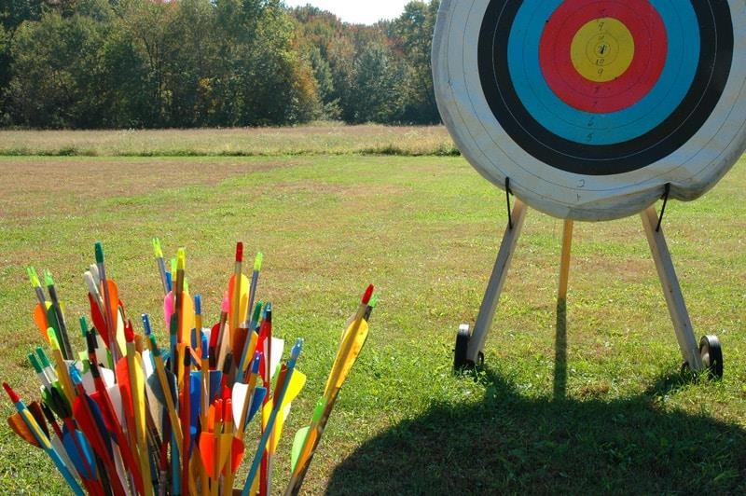
DIAMOND ARCHERY
SUMMER CAMP 2021
3 Sessions Available
JUNE 7-11 $125 Per Archer
JUNE 21-25

Monday-Friday 10AM-2PM
- Equipment Rental = $40/week

- Archers will need to Bring a Lunch

- Archers need to have at least 6 Arrows

[Type the sidebar content. A sidebar is a standalone supplement to the main document. It is often aligned on the left or right of the page, or located at the top or bottom. Use the Drawing Tools tab to change the formatting of the sidebar text box.]
JULY 12-16

10502 E 26th Cir. N
Wichita KS 67226
316-265-0651

