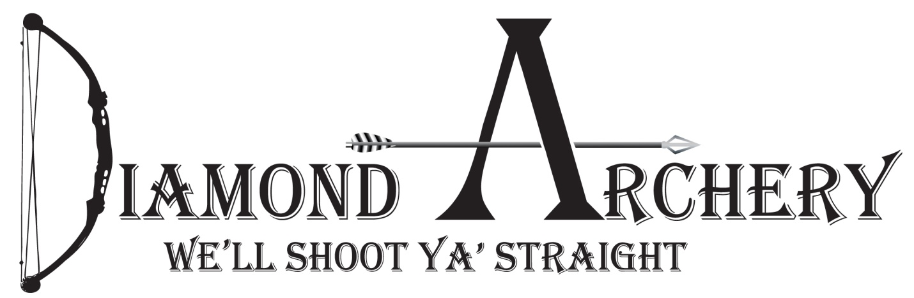
8th Annual Big buck Contest: Whitetail only
First Place: Choice of flagship bow from Mathews ($1,000)
Embroidered Carhartt Jacket with name and score on it.
Second place: Full shoulder mount. By: Jerry Kissinger ($500)
Third place: Yeti Tundra 45 ($350)
Fourth place: Delta 3D Big Daddy Deer Target ($250)
Fifth Place: Tight Spot Quiver ($140)
Big 8: Highest grossing 8 pointer will win the Obsession Turmoil.
Big 6: Highest grossing 6 pointer will get 6 hunting arrows.
$30 to enter, this includes banquet/must be entered by October 1, 2017
Didn’t get a buck this year? Don’t eat your tag, bring it to the banquet and use it as a raffle ticket to win a thermal Hog hunt From Rafter F Hunts.(Must be present to win)
Total gross inches will determine total score. Measuring will be done by Jerry Kissinger. You must be registered prior to killing animal. Animal must be taken with archery equipment. Cross bows are considered archery equipment Animal must be tagged by Dec 31st. 2017. Past 2 years winners will not be eligible for Prizes. If you win this year you will not be eligible to win again for 2 years. Call Diamond Archery for more details 316-265-0651.
Date for Banquet to be announced after the season. Mathews is donating a mission crossbow to be given away at the banquet. We will also have other door prizes at the banquet. (Must be present to win)

