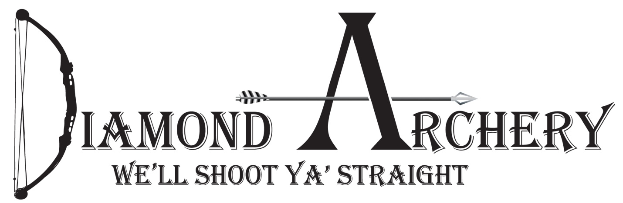
11th Annual Big buck Contest: Whitetail only
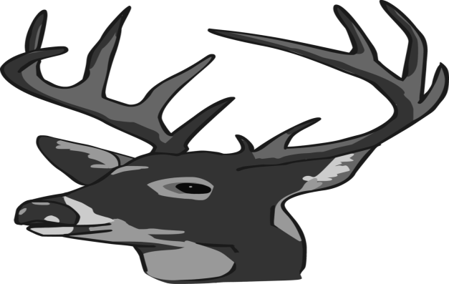
First Place: 2021 flagship bow from Mathews ($1,000)
Embroidered Carhartt Jacket with name and score on it.
Second place: Full shoulder mount. By: Jerry Kissinger ($550)
Third place: Black Gold Mountain Lite Sight ($225)
Fourth place: One Dozen Victory RIP TKO Arrows($200)
Fifth Place: Tight Spot Quiver ($150)
Big 8: Highest grossing 8 pointer will win a Full Shoulder Mount By Bailey Taxidermy. (Big 8 can only have 8 scoreable points)
Big 6: Highest grossing 6 pointer will get 6 hunting arrows.
$30 to enter, this includes banquet/must be entered by October 1, 2020
Total gross inches will determine total score. Measuring will be done by Jerry Kissinger. You must be registered prior to killing animal. Animal must be taken with archery equipment. Cross bows are considered archery equipment Animal must be tagged by Dec 31st. 2020. Past 2 years winners will not be eligible for Prizes. If you win this year you will not be eligible to win again for 2 years. Call Diamond Archery for more details 316-265-0651.

Big Buck Banquet
This is a fun event. Enjoy good Food and Hunting stories. Bring your mounts/antlers and tell us about the hunt. We will notify everyone two weeks prior to the event. Banquet will be sometime in the month of February. We will also be giving away door prizes (must be present to win)

