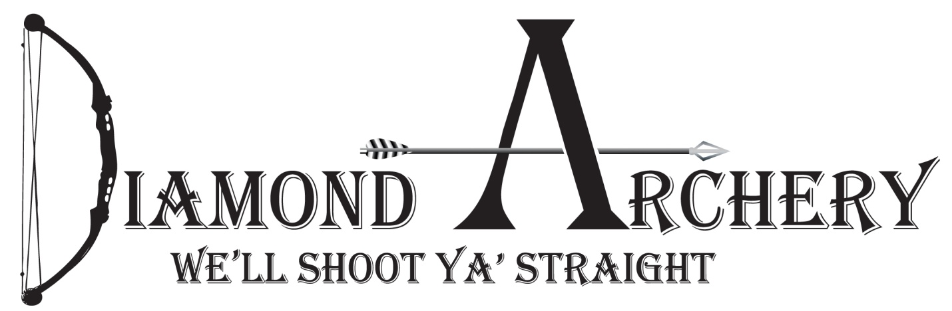
10th Annual Big buck Contest: Whitetail only
First Place: 2020 flagship bow from Mathews ($1,000)
Embroidered Carhartt Jacket with name and score on it.
Second place: Full shoulder mount. By: Jerry Kissinger ($500)
Third place: One Dozen Victory RIP TKO Arrows($200)
Fourth place: Tight Spot Quiver ($145)
Fifth Place: Apex Covert Sight ($120)
Big 8: Highest grossing 8 pointer will win a Full Shoulder Mount By Bailey Taxidermy. (Big 8 can only have 8 scoreable points)
Big 6: Highest grossing 6 pointer will get 6 hunting arrows.
$30 to enter, this includes banquet/must be entered by October 1, 2019
Tag Soup Prize TBD
Total gross inches will determine total score. Measuring will be done by Jerry Kissinger. You must be registered prior to killing animal. Animal must be taken with archery equipment. Cross bows are considered archery equipment Animal must be tagged by Dec 31st. 2019. Past 2 years winners will not be eligible for Prizes. If you win this year you will not be eligible to win again for 2 years. Call Diamond Archery for more details 316-265-0651.
Date for Banquet to be announced after the season. We will also have other door prizes at the banquet. (Must be present to win)

