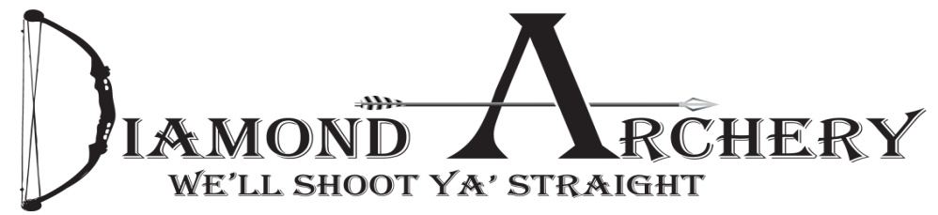

Midwest Hunt Fest 3-D Archery Shoot

Archery 3-D Shoot

Shooting Dates & Times:
- Friday, July 29th 1pm - 8pm
- Saturday, July 30th 10am - 7pm
- Sunday shoot off starts at 10:30

Cost: $10 per round

Format & Equipment:
- Bow hunting equipment only. (Bow Hunter class is limited to a 12” or less stabilizer measured from front bushing, fixed pins, a single pin movable sight can be shot but you cannot move during competition and no magnification, Side bars/v-bars are allowed nothing over 12”. Arrows Must have screw in points.)
- A 10 target round with two 5 target ends
- Shooters have 3 minutes to shoot each end ( shooter can shoot when green light comes on and the yellow light will come on to give a 20 second warning. If a shot is not fired when the red light comes on that shot will not count.
- Must have 5 arrows with field points – NO broadheads
- NO crossbows
- Arrows must weigh at least 5 grains per pound of the bows actual draw weight unless arrow does not exceed 280 fps. (A variance of 2 pounds of draw weight will be allowed for bow scale variation, and a 3% variance will be tolerated for the chronograph).
- Any binoculars, regardless of power are allowed.
- No range finders.
- No devices can be used to help “brace” the shot such as shooting sticks.
- Shooters will shoot from a designated shooting spot and will be supervised by a shoot official.

Scoring:
- All targets consist of 3-D type target having an offset 12 ring surrounded by a 10 ring and a larger 8 ring. Some targets will have a 14 ring that can be shot and scored.
- An arrow embedded in the hoof or horn of an animal is considered a miss and will score a zero.
- Targets consisting of material surrounding the animal body outline are also not considered body shots and arrows embedded in such surrounding material should be scored as zero.
- Arrows will be scored and pulled by a shoot official. (Shooter can ask for a second opinion if he feels it is close)
- If one or more scoring area is visible on the target, there will be a sign indicating the correct scoring area to shoot.
-arrow must stick to the target to be scored
- Arrow embedded in another arrow will be scored the same as the arrow embedded in the target.
- Arrow that hits another arrow and bounces back will be scored as the arrow embedded in target.
- Arrow that hit another arrow and continue to hit the target, are scored where they lie in the target.
- An arrow accidently dropped can be picked up and shot.
- An arrow propelled by the string in a forward direction is to be scored. (In the case of a letdown, an arrow dropped when it comes to a complete let-down can be reshot but if it leaves the bow in a forward direction during let-down it is considered a shot arrow)

-Once a shooter starts to shoot a round and there is a mechanical failure he may stop and reshoot a new round. The mechanical malfunction will be approved by an official. (Archers will be supervised by shoot officials and any mechanical failures due to archers fault will not be allowed to reshoot)
- Equipment failure in the shoot off will be considered extremely bad luck and archer will forfeit.
- The scoring official will do his best to score the arrow. If any part of the arrow is touching any part of the line the shooter will receive credit for that score.
- Shooter must stay in their shooting lane till the official has cleared the line. If a shooter advances it will be assumed he has finished that round. Line will not be cleared till red line comes on.
- If an official sees a shooter sky draw they will get one warning and if they do it again they will be stopped immediately and forfeit that round.
- Shooter does not have to shoot the targets in order.
- Before you shoot make sure you can see all the targets after the light goes on it is too late.
- The targets will be marked on the floor so everyone will have the same shot
- No warm up shooting is allowed at the event sight. Diamond Archery is located at 10502 E 26th cir. Wichita, KS 67226 that has an indoor/outdoor range for shooting.
Friday SHOOT

Cost: $10 per round (kids and woman shoot free unless shooting for prize $$)
- Shooters can shoot as many rounds as they can to achieve the highest possible score!
- We will pay back 70% to top 3 scores.
- First 50% of pot
- Second 30% of pot
- Third 20% of pot

Saturday Shoot

Cost: $10 per round
- Shoot as many rounds as you like to qualify
- Bow hunting equipment only
- Top 16 scores will qualify for the Sunday shot off
- Youth 16 years and younger can shoot for $5

Sunday Shoot-Off Prizes
1st Place = $400 2nd Place = 250
3rd Place = $100
+++All rules and regulations are at Diamond Archery’s discretion+++
Any Questions to the rules or format must be asked prior to shooting.

For more information: Call Diamond Archery at 316-265-0651

Thanks to all our generous sponsors
Sunday shoot off
1st
16th
2nd
15th
3rd
14th
4th
13th
5th
12th
6th
11th
7th
10th
8th
9th

